What is Reverse Engineering in Java?
✅ Definition
Reverse Engineering in Java is the process of analyzing existing Java software (compiled code or design) to understand its structure, logic, and behavior, without having original source documentation.
👉 In simple words:
Going from “already built software” → back to “design / code understanding”

🔁 Forward vs Reverse Engineering (Quick Comparison)
Forward Engineering | Reverse Engineering
UML → Code | Code → UML
Design first | Existing system
New application | Legacy application
Planned | Investigative

🔷 Why Reverse Engineering is Used in Java?
Reason | Explanation
Understand Legacy Code | No documentation available
Bug Fixing | Understand logic before fixing
Migration | Old Java → New Java / Microservices
Learning | Understand how frameworks work
Maintenance | Safely enhance existing systems

🔷 Simple Reverse Engineering Example (Java)
📌 Scenario
You receive a compiled Java application (.class / .jar) but no source code.

🔹 Original Java Code (Unknown to You)
public class Calculator {
public int add(int a, int b) {
return a + b;
}
}

🔹 After Reverse Engineering (Recovered Code)
public class Calculator {
public int add(int a, int b) {
return a + b;
}
}
👉 Using reverse engineering tools, you can decompile and understand:
- Class name
- Methods
- Logic
- Parameters
⚠️ Comments and exact formatting may not be recovered.

🔷 Reverse Engineering Flow in Java

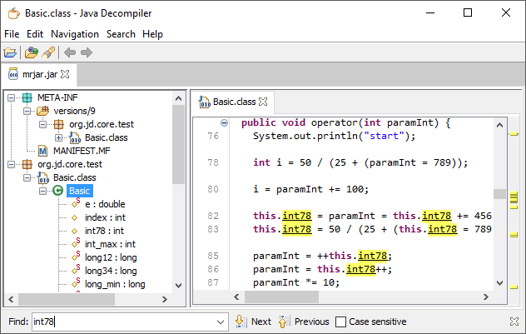
🔄 Flow:
.class / .jar file
↓
Decompiler / IDE
↓
Java source (approx.)
↓
UML diagrams
↓
Understanding / Modification

🔷 Steps for Reverse Engineering in Java

🟢 Step 1: Get the Existing Java Artifact
You may have:
- .class file
- .jar file
- Existing Java project (no UML)

🟢 Step 2: Decompile the Code
Convert bytecode → readable Java
🔹 Example output:
public class EmployeeService {
public void save() {
System.out.println("Saved");
}
}

🟢 Step 3: Analyze Code Structure
Understand:
- Packages
- Classes
- Methods
- Relationships

🟢 Step 4: Generate UML Diagrams
Create:
- Class Diagram
- Sequence Diagram
👉 This helps visualize the system

🟢 Step 5: Document & Improve
- Add documentation
- Refactor
- Fix bugs
- Extend features

🔷 Reverse Engineering Using IntelliJ IDEA (Java)
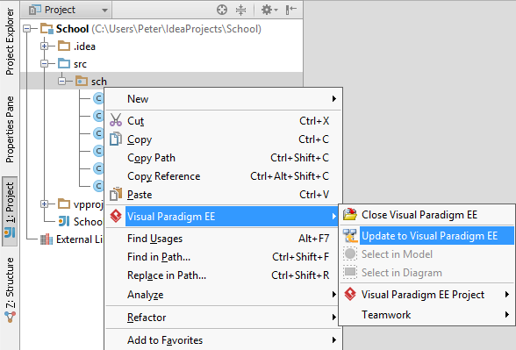
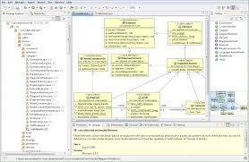
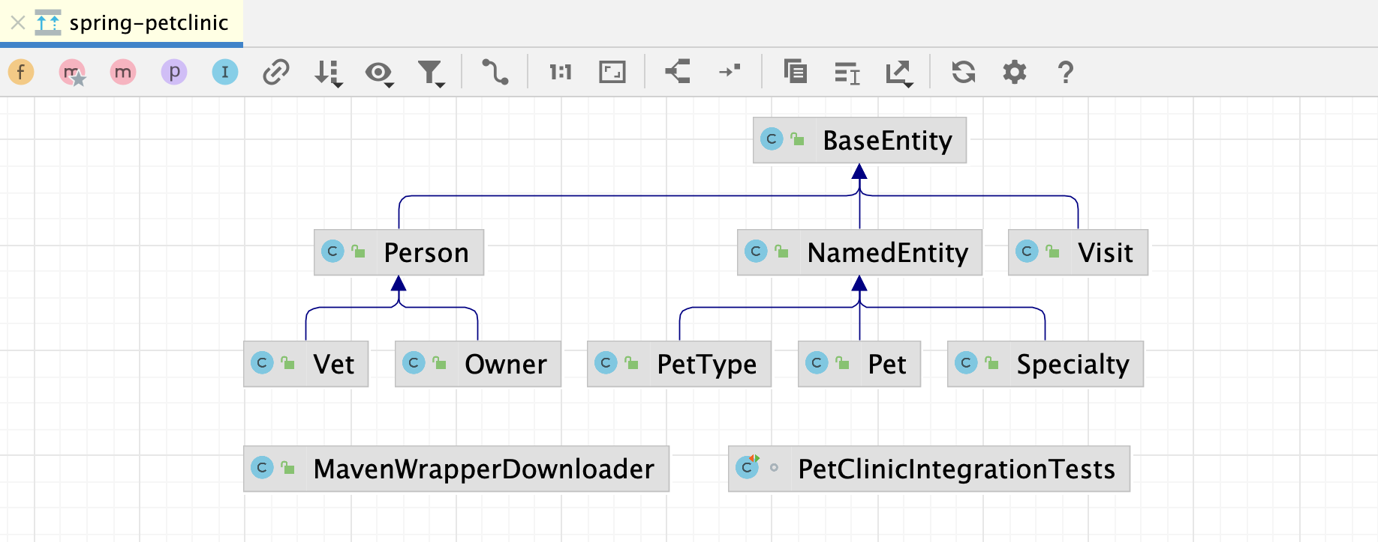
🔹 Steps:
- Open Java project
- Right-click package / class
- Diagrams → Show Diagram
- Select Java Class Diagram
- UML auto-generated
✔ Works best in IntelliJ Ultimate

🔷 Tools Used for Reverse Engineering in Java

🛠️ 1. JD-GUI (Decompiler)
✅ Use
- Open .class / .jar
- View Java source
✔ Free
✔ Very popular

🛠️ 2. CFR / Procyon (CLI Decompilers)
java -jar cfr.jar myApp.jar
✔ Accurate decompilation
✔ Used by professionals

🛠️ 3. IntelliJ IDEA
Feature | Availability
Decompile bytecode | Community
UML diagrams | Ultimate

🛠️ 4. Eclipse IDE
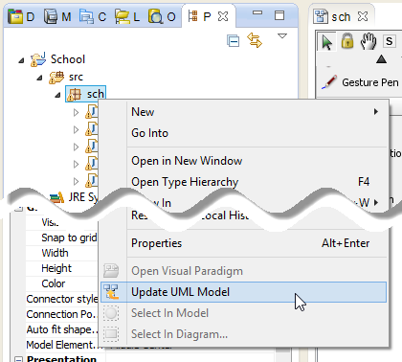
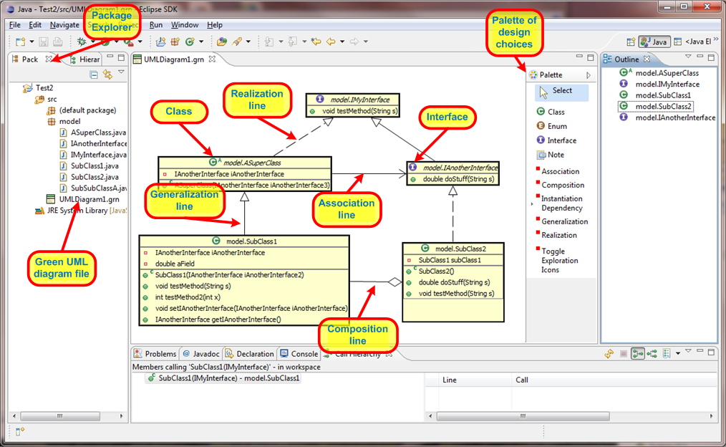
✔ Plugins available:
- ObjectAid UML
- UML Designer

🛠️ 5. Bytecode Viewers
- Bytecode Viewer
- JClassLib
Used for deep JVM-level analysis

🔷 What Reverse Engineering Cannot Do ❌
Limitation | Reason
Restore comments | Lost during compilation
Exact variable names | May be renamed
Original formatting | Not preserved
Legal bypass | License restrictions apply
⚠️ Always follow legal & licensing rules

🔷 Benefits of Reverse Engineering
Benefit | Explanation
Saves Time | No need to rewrite from scratch
Knowledge Recovery | Lost documentation restored
Safer Enhancements | Understand before change
Learning Tool | Study real-world systems

🔷 Interview-Ready One-Line Answers ⭐
- Reverse Engineering → Converting existing Java code or binaries into design or readable form
- Java Reverse Engineering → Bytecode → Java → UML
- Main Tools → JD-GUI, IntelliJ, Eclipse, CFR
- Main Use Case → Legacy system understanding

